Human Resource Plan
Organisational chart
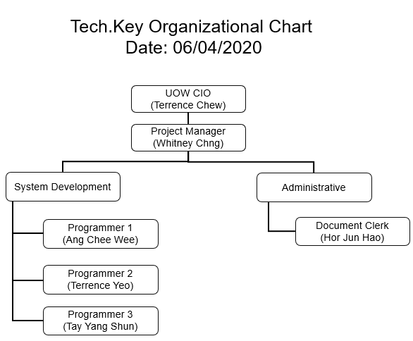

Name | Roles | Responsibility
Whitney Chng | Project Manager | Oversees all project matters, in-charge of most documentation of the project
Hor Jun Hao | Document Clerk | Assist the PM to complete relevant documents and provide necessary support to programming team
Ang Chee Wee | Programmer 1 | Create and design database (develop back-end code), develop system functionalities, run test cycles on prototype
Terrence Yeo | Programmer 2 | Create UI design (develop front-end code), develop system functionalities, create video demo
Tay Yang Shun | Programmer 3 | Create UI design (develop front-end code), develop system functionalities, fine-tune final prototype

